Faculty:

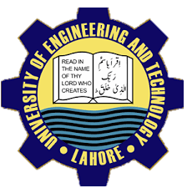

Facilities;

With the expansion in academic program, computer laboratories in the department have risen to nine spread over two buildings.The laboratories are equipped with 200+ computers fully network with state of the art server.

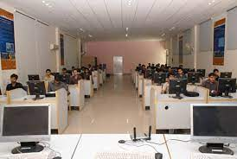

Computer to student ratio is 1:1. The department is proud of its privacy policy. Oracle has contributed software worth more 40 million.

* Prof. Dr. Khaldoon Khursheed
* Prof. Dr. Shazad( chairman )
* Professor Dr. Amaj Farooq

Contact detail:

For queries contact us on our official website.

[www.uet.edu.pk](http://www.uet.edu.pk)

or

call on:

03025332001

Prepared by: Amna Atiq

Roll no. 2023-ICS-359.

UNIVERSITY OF ENGINEERING AND TECHNOLOGY

A brief discussion of computer science and engineering department

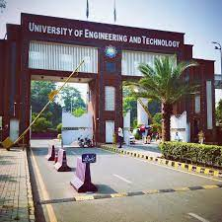

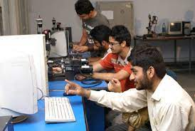

Here now we also offer double degree program. Three student each from the graduating class of computer science and computer engineering may opt for a second degree in computer science as the case may be subject to fulfillment of prescribe conditions, from fall semester 2011.

Research:

Estimate theory, signals processing, modern control and related areas, Data bases, semantic web and related areas.

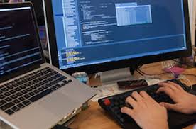

To the students of the department emphasizing entrepreneurship and ethical standards while encouraging them to remain abreast with latest developments in computing tools and processes and use their skills to identify and find solutions to society’s problems; and to use department’s resources and computing expertise to help industry, government and community in solving their problems.

Computer science jobs should be way more interesting than even going to wall street or being a lawyer—or, I can argue, than anything but perhaps biology, and there its just a tie. ~“Bill Gates..”

Degree & double degree Program:

Here we offer four year degree programs in terms of Bs (hons) which was introduced by the department in 1999. The degree of this program is affiliated by PEC (Pakistan engineering council).

PhD. Program in computer science was launched in 2002 and twenty six students have completed

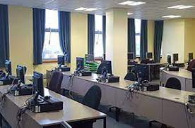Introduction:

The department of computer science and engineering was originally established as department of computer science in 1991. Its history dates back to the year 1968 when University of Engineering Technology Lahore established a computer centre. This centre was responsible for planning and teaching courses in Computer science and numerical analysis, which formed an intregal part of the curricular for all the desciplines of B.sc. The centre also offered short term computer courses for other private and public sector organization.

Mission:

To disseminate computing education